P1

1. f(n) = 12n−5, g(n) = 1235813n + 2017.

For O(g(n)), find c, n0,

make f(n) <= cg(n),

12n-5 <= 1235813n+2017,

(12-1235813c)n <= 2017c +5,

n<=(2017c+5)/(12-1235813c)

hence, contradiction as n cannot hold all n>n0, f is not order of g(n).

for omega(g(n)), find c, n0,

make f(n) >= cg(n),

same with above,

n >=(2017c+5)/(12-1235813c),

hence, exist n0 makes f(n) is omega of g(n).

1. f(n) = nlogn, g(n) = 0.00000001n.

assume the base is a,

For O(g(n)), find c, n0,

nlogn<= 0.00000001nc,

logn<= 0.00000001c,

n<=a^( 0.00000001c),

hence, contradiction as n cannot hold all n>n0, f is not order of g(n).

for omega(g(n)), find c, n0,

same with above,

n>=a^( 0.00000001c),

hence, exist n0 makes f(n) is omega of g(n).

1. f(n) = n^(2/3), g(n) = 7n^(3/4) + n^(1/10).

For O(g(n)), find c, n0,

n^(1/2)-cn^(2/15)<=7c,

for n^(1/2)-cn^(2/15) part, assume c = 1,

n^(1/2)-n^(2/15)<=7,

The derivation of the left side is 1/2 \* n ^(-1/2) – 2/5 \*n^(-13/15), Is 15/(30\*n^(15/30)) -4/(30\*n^(26/30)),

It’s bigger than 0 when n is sufficiently large, which means value of the left side will increase,

Let’s set the n = 10^10, the result is larger than 7,

hence, when n is big, there has a condition that does not suit for the function, contradiction as n cannot hold all n>n0, f is not order of g(n).

for omega(g(n)), find c, n0,

same with above,

n^(1/2)-cn^(2/15)>=7c,

the left side is increasing and there exist n’s that let it larger than 7,

hence, exist n0 makes f(n) is omega of g(n).

1. f(n) = n^1.0001, g(n) = nlogn.

For O(g(n)), find c, n0,

1/c <= n^(-0.0001)logn, noted as (1), assume the base is a,

Assume c = 10,000, a =10, when n = 100,000,000, the function works,

1/10000 <= 1/10,000 \* 8

For the right side of (1), the derivation for it is n^(-1/10000) \* 1/(n\*ln10) - 1/10000 \* n^(-10001/10000)\*logn, both of them are larger than 0 when n is large enough, I don’t know where the result of the derivation might below the 0, which means the value of (1) may decrease till smaller than 1/c, so complicated by hands.

Hence, I don’t know.

1. f(n) = n6^n, g(n) = (3n)^2.

For O(g(n)), find c, n0,

n\*(2/3)^n<=c,

The derivation of the left side is n \* (2/3)^n \* ln(2/3) + (2/3)^n, larger than 0 when n is big enough. Hence, n\*(2/3)^n will larger than c somehow.

Hence, contradiction as n cannot hold all n>n0, f is not order of g(n).

Reversely, for omega g(n),

exist n0 makes f(n) is omega of g(n).

P2

Log(n!) = theta (nlogn), base: 2

f(n)=log(n!), g(n)=nlogn,

For O(g(n)), find c, n0,

Log(n!) = logn + log(n-1) + …… + log(1) <= log n + …… + logn = nlogn,

Hence, f(n) <= cg(n), f is order of g(n).

for omega(g(n)), find c, n0,

log(n!) = logn + log(n-1) + …… + log(1) >= n/8 \* log(n/8) >= c logn,

Then we need to find at least a “c”,

n>=16,

logn>=4,

1/16 \* nlogn >= 1/4 \* n,

1/8 \* nlogn – 1/4 \* n >= 1/16 \* nlogn, all positive,

Hence, when c = 1/8, and n> n0 = 16, log(n!) is larger than c logn,

Which means f(n) is omega of g(n).

Hence, f(n) is theta of g(n).

P3

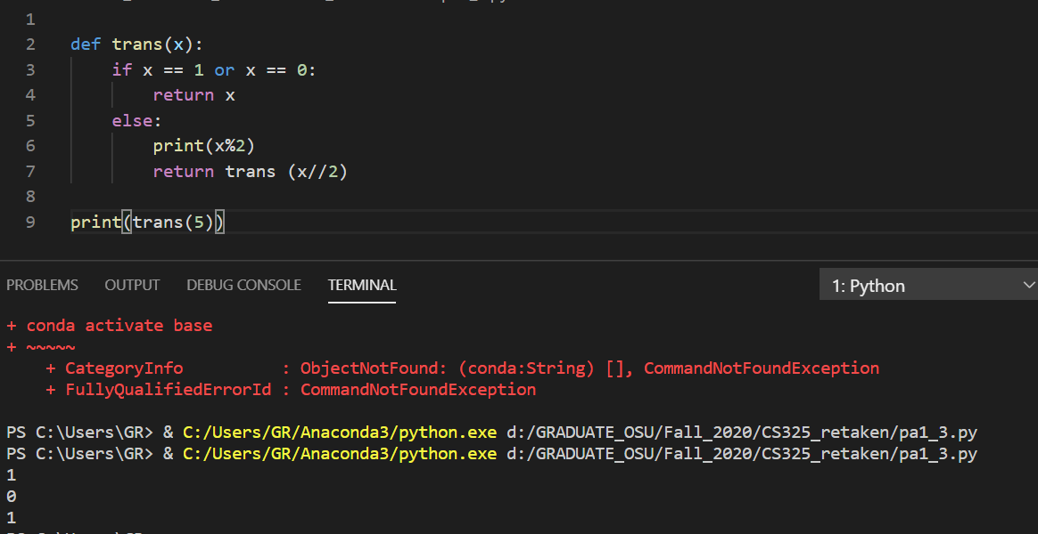

P4

Starting from the root node, and visit the left node of itself. Creating a new small tree and treat the node we mentioned as a new root. Keep doing that until the bottom left leaf. Then visit right leaf and back.

1

2 5

3 4 6 7

Postorder would find the most left and bottom one first and the right node match with it, then back to the subroot node.

7

3 6

1 2 4 5